Unit Guide to Benchmarking

1. Introduction
What is benchmarking in the NHS?
Benchmarking provides a platform for organisations to work together to improve services and meet ambitions set out in the NHS Long Term Plan and it provides; a structured approach for realistic and supportive practice development and allows practitioners to identify and compare best practice.

2. Purpose
There are many benefits to having a structured approach to quality measurement and service improvement. The advantages include:
- providing a systematic approach to the assessment of practice
- promoting reflective practice
- providing an avenue for change in clinical practice
- ensuring pockets of innovative practice are not wasted
- reducing repetition of effort and resources
- reducing fragmentation/geographical variations in care
- providing evidence for additional resources
- facilitating multidisciplinary team building and networking
- providing a forum for open and shared learning
- being practitioner led, and giving a sense of ownership
- accelerating quality improvement
- improving the transition of patients across complex organisational care pathways
- Contributing to the NMC revalidation process in both reflection and CPD elements. (RCN, 2017)

3. Scope
The benchmarking process in North East and Yorkshire (NEY) Adult Critical Care Networks has been established for many years and the process is continually evolving to ensure relevant benchmarks are developed and units collaborate to determine and standardise best practice interventions and drive quality improvement locally, across a network and the wider region. Participating units can be found in Appendix 1.

4. Process of benchmarking
Benchmarking follows a systematic process linked to improvement. The steps involved are demonstrated in figure 1.
- The benchmarking group will determine the priority areas of practice e.g. pressure ulcer prevention, tracheostomy care. The best practice evidence will be agreed by the group with input from experts in the field. E.g. Pressure ulcer prevention will include tissue viability specialist nurse input as well as evidence provided through National and Professional Standards.
- The group will agree the best practice interventions /outcome measures following the process below.
- Data collection, validation and submission should be carried out at individual unit level. There may be exceptions to this whereby the workforce, guidelines, leadership, practice and culture are the same across units.
- Unit data is shared at network and regional level with participating units and relevant network forums.
- Sharing of best practice and quality improvement is the focus of the collaborative benchmarking forum
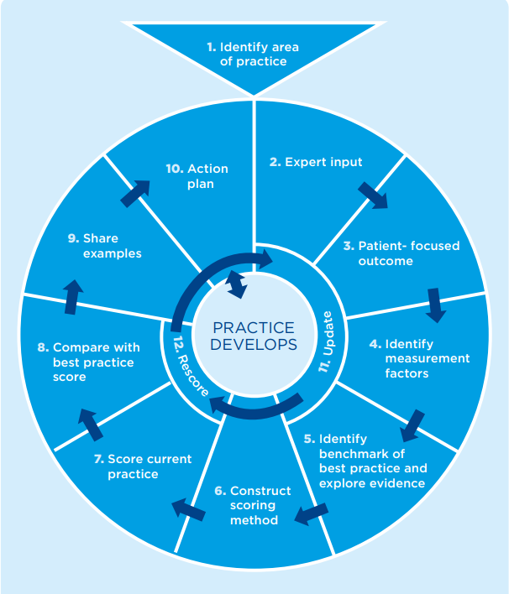
- The audit calendar is determined and agreed at the NEY Benchmarking meeting

Figure 1: The Benchmarking Wheel (RCN, 2017)

5. How to benchmark
- Units should determine the best approach to participation in the NEY benchmarking process.
- Some units identify a ‘lead’ to oversee the process. This includes; co-ordination of the audit timetable, submission of results to the network and follow up of any improvement actions required. This person does not carry out the data collection themselves, this would be carried out by champions of the scheduled topic e.g. the unit’s tissue viability link nurse would carry out the pressure ulcer prevention audit
- In other units, the ‘lead’ carries out all the audits for each scheduled topic.
- Each unit should have an identified contact person for benchmarking
- The audit process requires the assessment of care delivery against agreed evidence based standards and involves the review of care for 5 appropriate patients.
- The previous 24 hour period should be used to carry out the audit.
- For topics which may occur less frequently e.g. tracheostomy care, it is acceptable to review the care of one patient across 5 days which may or may not be consecutive.
- Units should ensure the governance process includes lead nurse review of local data prior to submission to the network
- Benchmark data should be submitted to the respective network by the 4th of the following month. E.g. if pressure ulcer prevention is the benchmark for June , the audit against the best practice interventions occurs during June and following senior nurse review and sign off of the results, data should be submitted to the network by the 4th July.
- Collated network data is emailed to: sam.rogers3@nhs.net two weeks prior to the regional benchmarking meeting
Collated network data will be presented at individual network forums as agreed

6. Benchmarking for Improvement
There are many tools available to support quality improvement (QI) in the NHS: https://www.england.nhs.uk/sustainableimprovement/qsir-programme/qsir-tools/ and networks are uniquely placed to support collaborative working across a wide geographical area, however local improvement is also an essential part of the benchmarking process. Following data collection at unit level and review by the senior nurse, it is imperative that critical care teams are included in the feedback of results and action planning, regardless of the level of compliance. Being proud of achievements can be motivating for teams and likewise, the ability to improve compliance with best practice interventions can be rewarding and could form part of an individual’s personal development plan. Targeting aspects of non -compliance should include collaboration with relevant members of the team e.g. link nurses, AHP’s, medical staff and critical care clinical educators.

7. Further Information
Further information regarding the benchmarking tools, audit calendar, links to resources and contact details can be found:
West Yorkshire: https://www.wyccn.org/regional-benchmarking-group.html
South Yorkshire & Bassetlaw: https://www.sybccn.org/benchmarking.html
North Yorkshire & Humberside:
North of England: North of England Critical Care Network - Benchmarking Group (noeccn.org.uk)

8. References
RCN (2017) Understanding Benchmarking: https://www.rcn.org.uk/Professional-Development/publications/pub-006333

Appendix 1 - NEY Critical Care Networks and Units

West Yorkshire Critical Care Network | Airedale ICU/HDU
 | Bradford ICU/HDU
 | Calderdale and Huddersfield ICU/HDU
 | Harrogate ICU/HDU
 | Pinderfields ICU/HDU
 | Leeds General Infirmary General ICU/HDU
 | Leeds General Infirmary Cardiac ICU/HDU
 | Leeds General Infirmary Neuro ICU/HDU
 | St James University Hospital General ICU/HDU (J54)
 | St James University Hospital ICU/HDU (J81)
South Yorkshire Critical Care Network | Barnsley ICU
 | Bassetlaw ICU
 | Doncaster ICU
 | Rotherham ICU
 | Northern General Hospital General ICU
 | Northern General Hospital Cardiac ICU
 | Royal Hallamshire Hospital General ICU
 | Royal Hallamshire Hospital Neuro ICU
Humber, Coast & Vale Critical Care Network | Royal Infirmary, Hull
 | Castlehill, Hull
 | Scarborough
 | York
 | Diana Princess of Wales, Grimsby
 | Scunthorpe
North of England Critical Care Network | Northumbria Specialist Emergency Care Hospital
 | Freeman Ward 37
 | Freeman Ward 21
 | RVI Ward 38
 | RVI Ward 18
 | South Tyneside
 | QE, Gateshead
 | Sunderland
 | Durham
 | Darlington
 | North Tees
 | James Cook - General
 | James Cook - Cardio
 | James Cook - Spinal
 | James Cook - Neuro
 | Cumberland Infirmary
 | West Cumberland

