

**Cheshire and Mersey Critical Care Network**



**Cardiology in Critical Care**

Workbook Series

Number:

**Created by**

Gemma Entwistle, Practice Educator, Critical Care Department, Liverpool Heart and Chest Hospital Foundation NHS Trust.

Claire Partridge, Practice Educator, Critical Care Department, Liverpool Heart and Chest Hospital Foundation NHS Trust.

Neville Rumsby, Practice Educator, Critical Care Department, Liverpool Heart and Chest Hospital Foundation NHS Trust.

|  |  |
| --- | --- |
| Version 1 | May 2014 |
| Status |  |
| Changes |  |
| Review date | May 2015 |
| Author | G Entwistle |
| Owner | Cheshire and Mersey Critical Care Network |

|  |  |
| --- | --- |
| Contents | Page |
| Introduction | 4 |
| Anatomy and Physiology – Blood flow | 5 |
| Anatomy and Physiology – Electrical conduction system | 6 |
| Electrocardiography | 7 |
| Pacemakers | 12 |
| Haemodynamic Monitoring | 13 |
| Management of arterial lines | 17 |
| Management of central venous pressure lines | 18 |
| Intra-aortic balloon pumps | 20 |
| Medications | 23 |
| Crossword | 24 |
|  | 26 |
|  |  |
|  |  |
|  |  |
|  |  |
|  |  |

**Introduction**

This workbook has been produced to assist healthcare professionals in critical care in caring for patients requiring cardiovascular monitoring and support, and those who have cardiovascular disease requiring interventions. Many of these patients require admission to critical care and application of subsequent treatments to prevent secondary problems.

The book provides questions regarding normal physiology, pathophysiology and cardiovascular assessment.

To determine your competence you are required to complete the following: -

1. Attendance at formal Trust/Unit training sessions.
2. Successful completion of the workbook.
3. Competency assessment

How to use this workbook

The workbook is divided into sections. There are questions and activities included which form an important part of your learning and training. Please attach separate sheets if needed.

**It is your evidence of learning.**

You will need to obtain and read several documents to assist you in completing this workbook and you will require access to books and other reference materials (see bibliography). When completed this workbook will form part of your evidence of learning, professional development and competence. Please keep this package in your portfolio as it could be used to gain further credits at university or college and assist in meeting KSF/PREP requirements.

**To help you with this work book, you need to revise the following:**

* **Anatomy and Physiology of the Cardiovascular System**

**Learning Outcomes**

Having completed this pack you will be able to:

* + State the anatomy and physiology of the cardiovascular system
  + Demonstrate a basic understanding of cardiovascular conditions which may require critical care
  + Demonstrate an understanding of cardiovascular monitoring used in critical care

**Label each chamber/vessel of the heart**

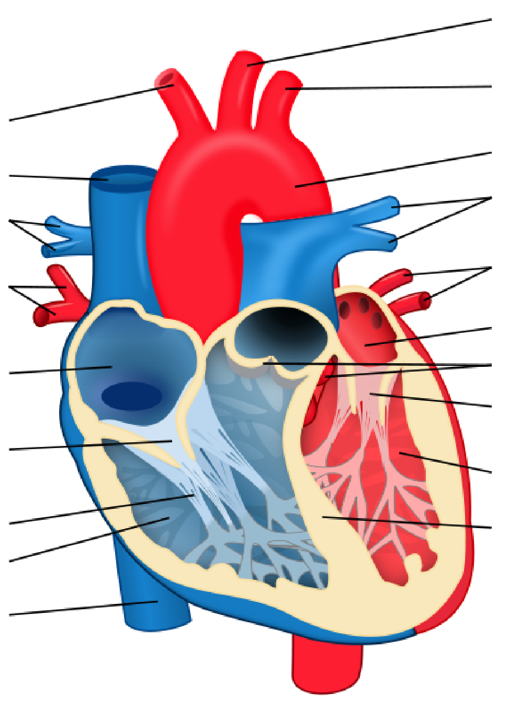

**10________________**

**11________________**

**1________________**

**12_______________**

**2________________**

**13_______________**

**3________________**

**14_______________**

**4________________**

**15_______________**

**5________________ 16_______________**

**17_______________**

**6________________**

**18_______________**

**7_________________**

**19_______________**

**8_________________**

**9_________________**

<http://en.wikipedia.org/wiki/File:Heart_diagram-en.svg>

**Describe the blood flow through the heart**

____________________________________________________________________________________________________________________________________________________________________________________________________________________________________________________________________________________________________________________________________________________________________________________________________________________________________________________________________________________________________________________________________________________________________________________________________________________________________________________________________________________________________________________________________________________________________________________________________________

**Label the electrical conduction system**

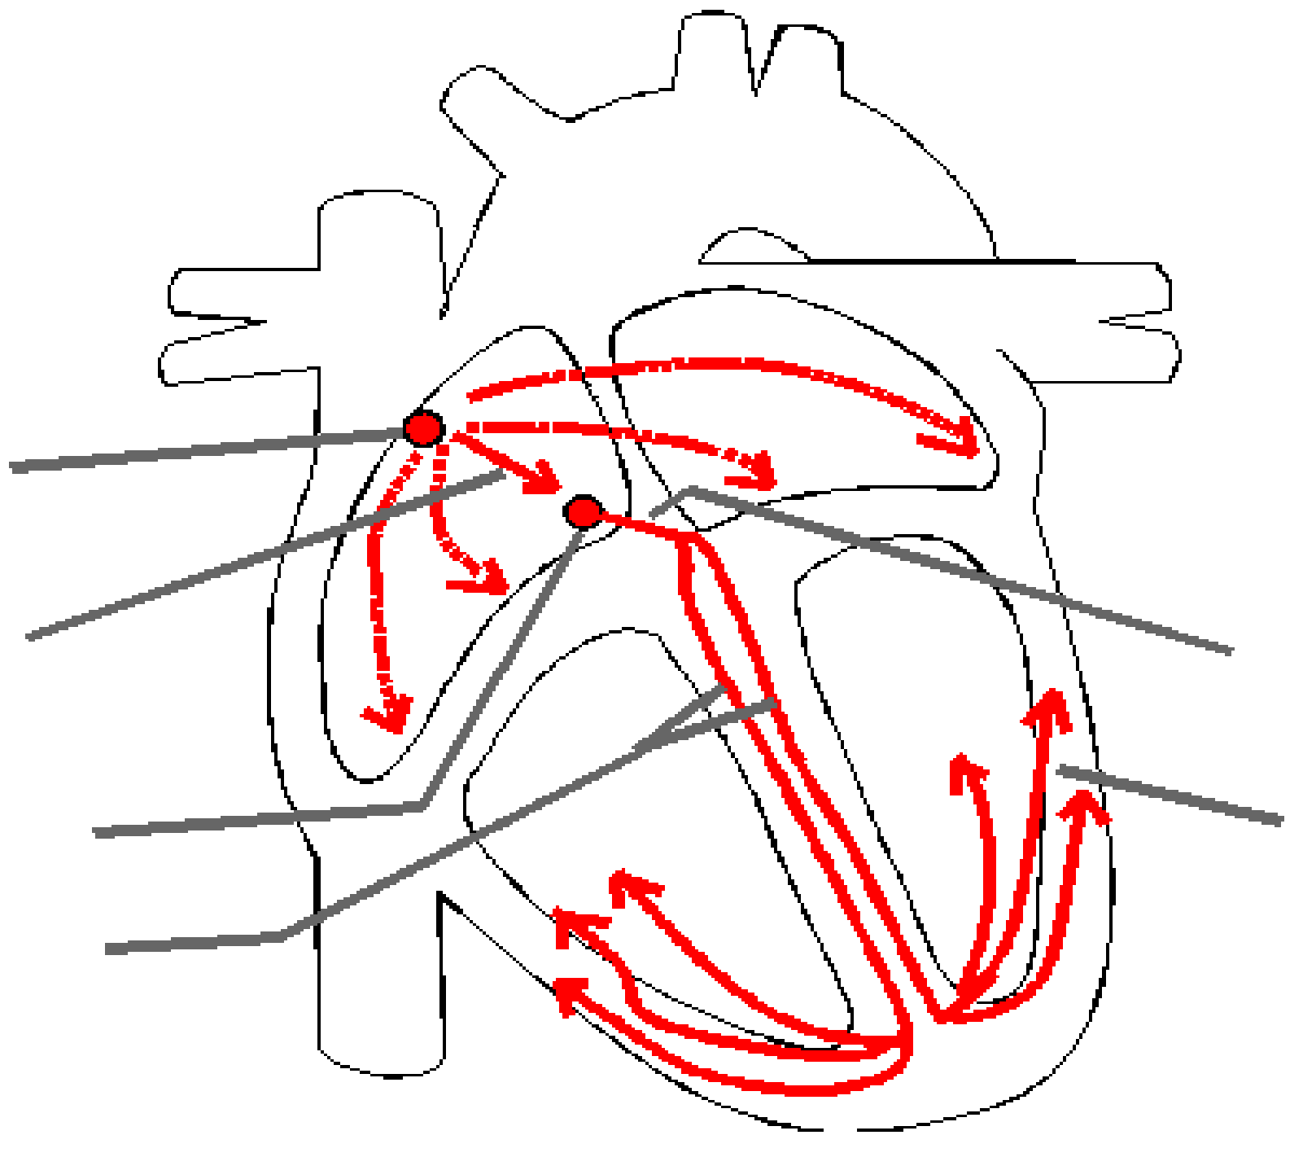

1__________

2__________ 4__________

3__________ 6__________

5__________

**Electrocardiography (ECG)**

Using the 6 steps to reading an ECG. State the rate, rhythm and treatment of the following ECGs:

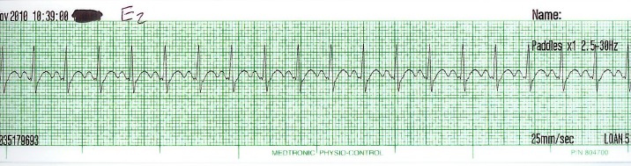

1. Rate____________________________________________________________________

Rhythm__________________________________________________________________

Treatment________________________________________________________________________________________________________________________________________

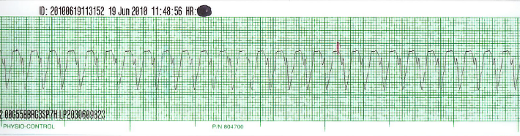

1. Rate____________________________________________________________________

Rhythm__________________________________________________________________

Treatment________________________________________________________________________________________________________________________________________

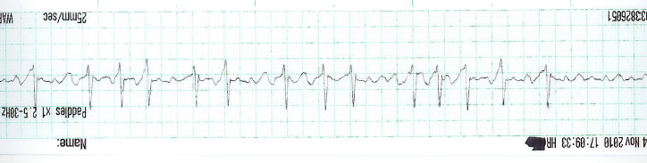

1. Rate____________________________________________________________________

Rhythm__________________________________________________________________

Treatment_________________________________________________________________________________________________________________________________________

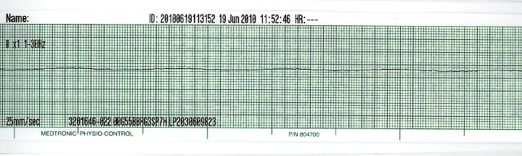

1. Rate____________________________________________________________________

Rhythm__________________________________________________________________

Treatment_________________________________________________________________________________________________________________________________________

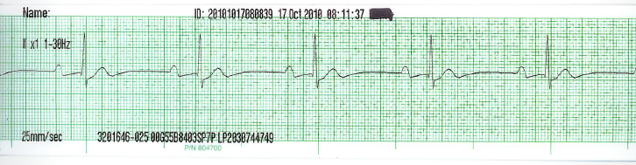

1. Rate____________________________________________________________________

Rhythm__________________________________________________________________

Treatment_________________________________________________________________________________________________________________________________________

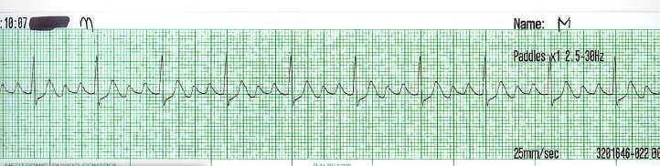

1. Rate____________________________________________________________________

Rhythm__________________________________________________________________

Treatment_________________________________________________________________________________________________________________________________________

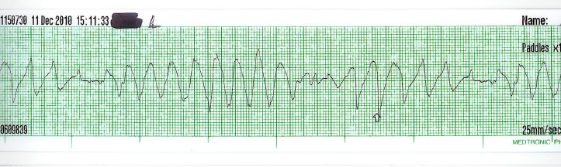

1. Rate____________________________________________________________________

Rhythm__________________________________________________________________

Treatment_________________________________________________________________________________________________________________________________________

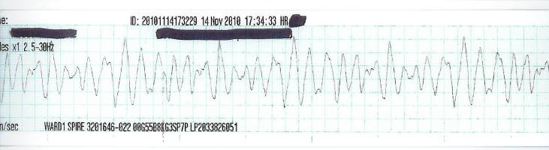

1. Rate____________________________________________________________________

Rhythm__________________________________________________________________

Treatment_________________________________________________________________________________________________________________________________________

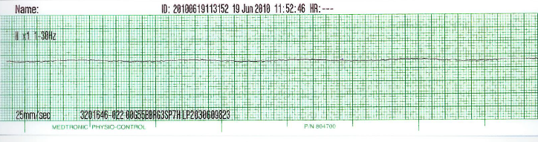

1. Rate____________________________________________________________________

Rhythm__________________________________________________________________

Treatment_________________________________________________________________________________________________________________________________________

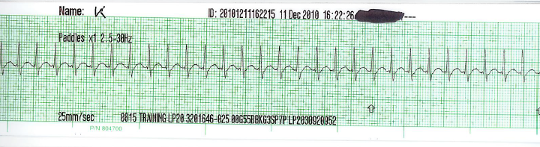

1. Rate____________________________________________________________________

Rhythm__________________________________________________________________

Treatment_________________________________________________________________________________________________________________________________________

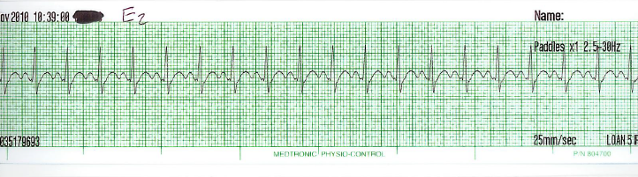

1. Rate____________________________________________________________________

Rhythm__________________________________________________________________

Treatment_________________________________________________________________________________________________________________________________________

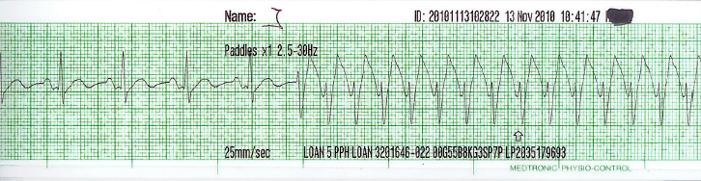

1. Rate____________________________________________________________________

Rhythm__________________________________________________________________

Treatment_________________________________________________________________________________________________________________________________________

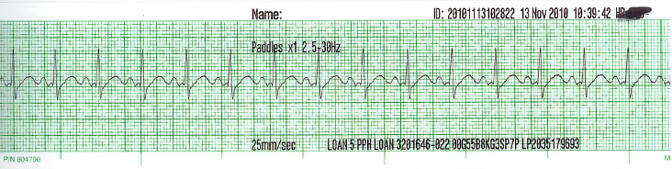

1. Rate____________________________________________________________________

Rhythm__________________________________________________________________

Treatment_________________________________________________________________________________________________________________________________________

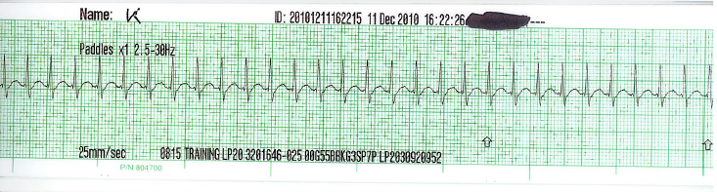

1. Rate____________________________________________________________________

Rhythm__________________________________________________________________

Treatment_________________________________________________________________________________________________________________________________________

**Pacemakers**

1. What is a pacemaker?

___________________________________________________________________________________________________________________________________________________________________________________________________________________________

1. List the types of pacemakers/devices with pacemaker function:

_____________________________________________________________________________________________________________________________________________________________________________________________________________________________________________________________________________________________________________________________________________________________________________

1. List the methods of pacing:

_____________________________________________________________________________________________________________________________________________________________________________________________________________________________________________________________________________________________________________________________________________________________________________

1. What are the considerations that need to be made for pacemakers?

____________________________________________________________________________________________________________________________________________________________________________________________________________________________________________________________________________________________________

1. Complete the table below in regards to pacemaker functions/generic anti-bradycardia code meanings:

|  |  |  |  |  |
| --- | --- | --- | --- | --- |
| I | II | II | IV | V |
|  |  |  |  |  |
|  |  |  |  |  |
|  |  |  |  |  |
|  |  |  |  |  |
|  |  |  |  |  |

**Haemodynamic Monitoring**

1. What is meant by the term haemodynamic monitoring?

________________________________________________________________________________________________________________________________________________________________________________________________________________________________________________________________________________________________________________________________________________________________

1. Define the following terms:
   1. Blood pressure (BP)

________________________________________________________________________________________________________________________________________________________________________________

* 1. Mean Arterial Pressure (MAP)

________________________________________________________________________________________________________________________________________________________________________________

* 1. Heart Rate (HR)

________________________________________________________________________________________________________________________________________________________________________________

* 1. Central Venous Pressure (CVP)

________________________________________________________________________________________________________________________________________________________________________________

* 1. Cardiac Output (CO)

________________________________________________________________________________________________________________________________________________________________________________

* 1. Stroke Volume (SV)

________________________________________________________________________________________________________________________________________________________________________________

* 1. Cardiac Index (CI)

________________________________________________________________________________________________________________________________________________________________________________

* 1. Systemic Vascular Resistance (SVR)

________________________________________________________________________________________________________________________________________________________________________________

1. What are the normal values/ranges of:
   1. Blood pressure (BP)

________________________________________________________________________________________________________________________________________________________________________________

* 1. Mean Arterial Pressure (MAP)

________________________________________________________________________________________________________________________________________________________________________________

* 1. Heart Rate (HR)

________________________________________________________________________________________________________________________________________________________________________________

* 1. Central Venous Pressure (CVP)

________________________________________________________________________________________________________________________________________________________________________________

* 1. Cardiac Output (CO)

________________________________________________________________________________________________________________________________________________________________________________

* 1. Stroke Volume (SV)

________________________________________________________________________________________________________________________________________________________________________________

* 1. Cardiac Index (CI)

________________________________________________________________________________________________________________________________________________________________________________

* 1. Systemic Vascular Resistance (SVR)

________________________________________________________________________________________________________________________________________________________________________________

1. What would cause a high/low reading for the following:
   1. Blood pressure (BP)

________________________________________________________________________________________________________________________________________________________________________________

* 1. Mean Arterial Pressure (MAP)

________________________________________________________________________________________________________________________________________________________________________________

* 1. Heart Rate (HR)

________________________________________________________________________________________________________________________________________________________________________________

* 1. Central Venous Pressure (CVP)

________________________________________________________________________________________________________________________________________________________________________________

* 1. Cardiac Output (CO)

________________________________________________________________________________________________________________________________________________________________________________

* 1. Stroke Volume (SV)

________________________________________________________________________________________________________________________________________________________________________________

* 1. Cardiac Index (CI)

________________________________________________________________________________________________________________________________________________________________________________

* 1. Systemic Vascular Resistance (SVR)

________________________________________________________________________________________________________________________________________________________________________________

1. List/identify the tools/equipment used for haemodynamic monitoring:

________________________________________________________________________________________________________________________________________________________________________________________________________________________________________________________________________________________________________________________________________________________________________________________________________________________________________________________

1. You have been asked to prepare the equipment for invasive haemodynamic monitoring, state what equipment you will need:

________________________________________________________________________________________________________________________________________________________________________________________________________________________________________________________________________________________________________________________________________________________________________________________________________________________________________________________________________________________________________________________________________________________________________________________________________________________________________

1. The flush device ensures that the flush solution will be delivered at a rate of ___ ml/hr to keep the catheter open when the pressure bag is maintained at ___mmHg.
2. The air (zero) reference point (transducer plate) for quality assurance purposes is located at:

______________________________space or _________________________ ­­­­­­­­­­­­­­­­­­­­­­axis

1. ___________________________ readings will be produced if the air (zero) reference is in the incorrect position.
2. Why do we re-zero the transducer and how often should this be done?

________________________________________________________________________________________________________________________________________________________________________________

**Management of arterial lines**

1. What are the possible causes of a high arterial blood pressure reading? How would you treat this?

________________________________________________________________________________________________________________________________________________

1. What are the possible causes of a low arterial blood pressure reading? How would you treat this?

________________________________________________________________________________________________________________________________________________

1. In relation to the arterial blood pressure, what is meant by the term overshooting? How would you treat this?

________________________________________________________________________________________________________________________________________________

1. In relation to the arterial blood pressure, what is meant by the term dampened trace? How would you treat this?

________________________________________________________________________________________________________________________________________________

1. List the possible insertion sites for an arterial line and their risks/benefits:

________________________________________________________________________________________________________________________________________________

1. What are the possible complications of insertion of an arterial line?

________________________________________________________________________________________________________________________________________________________________________________

1. How would you remove an arterial line?

________________________________________________________________________________________________________________________________________________________________________________

**Management of central lines**

1. What are the possible causes of a high central venous pressure reading? How would you treat this?

________________________________________________________________________________________________________________________________________________

1. What are the possible causes of a central venous reading? How would you treat this?

________________________________________________________________________________________________________________________________________________

1. In relation to the central venous pressure, what is meant by the term dampened trace? How would you treat this?

________________________________________________________________________________________________________________________________________________

1. List the possible insertion sites for an central venous pressure line and their risks/benefits:

________________________________________________________________________________________________________________________________________________

1. What are the possible complications of insertion of a central venous pressure line?

________________________________________________________________________________________________________________________________________________________________________________

1. How would you remove an central venous pressure line?

________________________________________________________________________________________________________________________________________________________________________________

1. What are the possible causes of a high CVP, a low CVP and how would you treat them?

________________________________________________________________________________________________________________________________________________

1. What are the possible complications of insertion of a CVP line?

________________________________________________________________________________________________________________________________________________

1. How would you remove a CVP line?

________________________________________________________________________________________________________________________________________________

1. What might be the treatment/prescrition for the following conditions?

*Hypovolaemia*

__________________________________________________________________________________________________________________________________________________

___________________________________________________________________________________________________________________________________________________________________________________________________________________________

*Dehydration*

__________________________________________________________________________________________________________________________________________________

___________________________________________________________________________________________________________________________________________________________________________________________________________________________

*Haemorrhage*

__________________________________________________________________________________________________________________________________________________

___________________________________________________________________________________________________________________________________________________________________________________________________________________________

1. What is cardiac tamponade?

__________________________________________________________________________________________________________________________________________________

___________________________________________________________________________________________________________________________________________________________________________________________________________________________

1. What are the signs and symptoms of cardiac tamponade?

__________________________________________________________________________________________________________________________________________________

___________________________________________________________________________________________________________________________________________________________________________________________________________________________

**Intra -Aortic Balloon Pump (IABP)**

1. Why do we use the IABP?

________________________________________________________________________________________________________________________________________________________________________________________________________________________________________________________________________________________________________________________________________________________________

1. Define the following terms in relation to the IABP:
   1. Augmented pressures:

________________________________________________________________________________________________________________________________________________________________________________

* 1. Ratio:

________________________________________________________________________________________________________________________________________________________________________________

* 1. Mean:

________________________________________________________________________________________________________________________________________________________________________________

* 1. Inflation timing:

________________________________________________________________________________________________________________________________________________________________________________

* 1. Deflation timing:

________________________________________________________________________________________________________________________________________________________________________________

1. Why is the timing of the balloon inflation critical?

________________________________________________________________________________________________________________________________________________________________________________________________________________________________________________________________________________________________________________________________________________________________

1. List the trigger recognition and the criteria:

________________________________________________________________________________________________________________________________________________________________________________________________________________________________________________________________________________________________________________________________________________________________

1. Where can the catheter be placed and what can go wrong if the catheter is misplaced?

________________________________________________________________________________________________________________________________________________________________________________________________________________________________________________________________________________________________________________________________________________________________

________________________________________________________________________________________________________________________________________________________________________________

1. How can you position your patient when an IABP catheter is in situ:

________________________________________________________________________________________________________________________________________________________________________________________________________________________________________________________________________________________________________________________________________________________________________________________________________________________________________________________

1. How often should you zero the IABP and what considerations in doing this should you make: ________________________________________________________________________________________________________________________________________________________________________________________________________________________________________________________________________________________________________________________________________________________________________________________________________________________________________________________________________________________________________________________________________________________________________________________________________________________________________
2. The flush device ensures that the flush solution __________________will be delivered at a rate of ___ ml/hr. to keep the catheter open when the pressure bag is maintained at ___mmHg.
3. The air (zero) reference point (transducer plate) for quality assurance purposes is located at:

______________________________space or _________________________ ­­­­­­­­­­­­­­­­­­­­­­axis

1. ___________________________ readings will be produced if the air (zero) reference is in the incorrect position.
2. What gas is in the cylinder and how long does a full cylinder last?

________________________________________________________________________________________________________________________________________________________________________________

1. List/identify problems associated with the IABP:

________________________________________________________________________________________________________________________________________________________________________________

________________________________________________________________________________________________________________________________________________________________________________________________________________________________________________________________________________________________________________________________________________________________

1. IF you saw blood in the line from the patient, what would you do?

________________________________________________________________________________________________________________________________________________________________________________________________________________________________________________________________________________________________________________________________________________________________________________________________________________________________________________________________________________________________________________________________________________

1. List further complications and nursing criteria:

________________________________________________________________________________________________________________________________________________________________________________________________________________________________________________________________________

1. List possible alarm, alerts and rationale to troubleshoot:

________________________________________________________________________________________________________________________________________________________________________________________________________________________________________________________________________

**Medications**

1. During your initial safety checks at the commencement of your shift you notice there are 2 noradrenaline infusions running simultaneously at various strengths and rates. What do you need to do?

_________________________________________________________________________________________________________________________________________________

___________________________________________________________________________________________________________________________________________________________________________________________________________________________

1. What are inotropes? Name 2 inotropes used in Critical Care.

__________________________________________________________________________________________________________________________________________________

___________________________________________________________________________________________________________________________________________________________________________________________________________________________

1. What are the side effects of inotropic use?

__________________________________________________________________________________________________________________________________________________

___________________________________________________________________________________________________________________________________________________________________________________________________________________________

1. Why is a high potassium dangerous?

__________________________________________________________________________________________________________________________________________________

___________________________________________________________________________________________________________________________________________________________________________________________________________________________

1. Name 3 methods of reducing a high potassium.

__________________________________________________________________________________________________________________________________________________

___________________________________________________________________________________________________________________________________________________________________________________________________________________________

**Crossword**

**Across**

9 Inferior tip of the heart (4)

10 Measures the strength of the cardiac action potential cycles (17)

11 Name of the sounds that you would hear when taking a non-invasive blood pressure (9)

12 Size of a normal QRS complex (5, 5, 7)

14 Active phase of cardiac action (14)

15 Vessels that take blood to the lungs (9, 8)

16 The P wave represents (6, 14)

17 Divides the ventricles (6)

18 Space between the linings of the heart (11, 6)

19 Heart attack (10, 10)

20 This rhythm is irregularly irregular (6, 12)

22 Initiates the signal causing atrial contraction (4, 6, 4)

23 Collagen cords that are attached to the AV valves (7, 8)

26 Where is the air reference point in regards to the transducer (12, 4)

**Down**

1 Largest chamber of the heart (4, 9)

2 What does Stroke Volume and Heart Rate determine (7, 6)

3 A potentially reversible cause of a cardiac arrest (13)

4 Doubled walled sac that surrounds the heart (11)

5 Right AV Valve (9)

6 Artery that supplies the lateral myocardium (10)

7 What sensors measure pressure in the Aortic body (4, 9)

8 The QRS complex represents (11, 14)

13 A small depression on the medial wall (5, 6)

21 ST elevation in leads II, III, aVF indicates (8, 1, 1)

24 Largest vein in the body (4, 4)

25 On the arterial waveform what signifies the close of the Aortic valve (8, 5)

27 Composed of cardiac muscle (5)

28 Non-shockable rhythm (8)

29 Extensions of the atria (8)

30 A hole in the wall that divides the heart (6, 6)

